Detailed Design Document
for
STEMultator: AI Powered Science Lab Simulator for STEM Education Students
Team Members: Nathan Gulley
Gideon Idowu
Ahmed Kareem
To: Prof. Worrel Morgan
Regis University
MSSE692 Software Engineering Practicum I
1. API Specification
1.1 Create Science Lab
Description: Creates a ScienceLab JSON object that contains the metadata, learning goals and lesson plan needed to run an interactive and guided simulation of a STEM science lab. Saves the JSON object to a database then returns it to the caller.
Method: POST
URL Path: /stemulator/v1/labs
Parameters:
Name | Type | Required | Description
labId | form-data | true | Unique identifier for a science lab (e.g. HS-PS2-1)
discipline | form-data | true | The science discipline that the lab falls under (e.g. Physical Science, Life Science, Earth and Space Science)
topic | form-data | true | One of the topics that falls under the specified science discipline (e.g. Biological Evolution: Unity and Diversity)
subTopic | form-data | true | One of the subTopics that falls under the specified topic (e.g. Natural Selection)
expertise | form-data | true | The field that the AI Science Guide has Phd level expertise in
simulation | form-data | true | The name of the simulation application
screenshot | form-data | true | A screenshot of the simulation application’s UI
Sample Request:
curl --location 'http://localhost:8080/stemulator/v1/labs' \
--form 'labId="HS-PS2-1"' \
--form 'discipline="Physical Science"' \
--form 'topic="Motion and Stability: Forces and Interactions"' \
--form 'subTopic="Forces and Motion"' \
--form 'expertise="Physics"' \
--form 'simulation="Gravity Force"' \
--form 'screenshot=@"/C:/Users/tmp/gravity_force_lab.jpg"'
Sample Response:
See Appendix 7.1 Response JSON - ScienceLab
Response Codes:
Code | Name | Meaning
201 | Created | Request was successful
500 | Internal Server Error | Server failure
1.2 Get Science Lab
Description: Fetches a ScienceLab JSON object from the database that matches the specified labId and returns it to the caller.
Method: GET
URL Path: /stemulator/v1/labs/:labId
Parameters:
Name | Type | Required | Description
labId | path | true | Unique identifier for a science lab (e.g. HS-PS2-1)
Sample Request:
curl --location 'http://localhost:8080/stemulator/v1/labs/HS-ESS1-4'
Sample Response:
See Appendix 7.1 Response JSON - ScienceLab
Response Codes:
Code | Name | Meaning
200 | OK | Request was successful
404 | Not Found | A science lab matching the specified labId doesn’t exist in the database
500 | Internal Server Error | Server failure
1.3 Get Science Lab List
Description: Fetches a list of all ScienceLab JSON objects from the database and returns it to the caller.
Method: GET
URL Path: /stemulator/v1/labs
Parameters: N/A
Sample Request:
curl --location 'http://localhost:8080/stemulator/v1/labs'
Sample Response:
See Appendix 7.2 Response JSON - ScienceLab List
Response Codes:
Code | Name | Meaning
200 | OK | Request was successful
500 | Internal Server Error | Server failure
1.4 Get Science Lab Guidance
Description: Provides personalized expert guidance to the student as they progress through the science lab. A request for guidance should be made after the student completes each part of a lab. The specific content of the guidance provided depends on the labId, lab partId, state of the current client UI setup, and the lists of observations, evidence and predictions submitted by the student.
Method: POST
URL Path: /stemulator/v1/guides/lab/:labId/part/:partId
Parameters:
Name | Type | Required | Description
labId | Path param | true | Unique identifier for a science lab (e.g. HS-PS2-1)
partId | Path param | true | A number 1 through 4 that specifies which part of the science lab the student is requesting guidance
evidence | form-data | true | A csv file that contains any data the student was instructed to collect for this part of the lab
scienceGuideRequest | form-data | true | A JSON string that encapsulates student provided information required to service a request for personalized expert guidance:  {  "studentName": "Barack",  "setup": [  "no starting traits are selected"  ],  "observations": [  "the closer their fur color is to the color of the environment, the less visible they are to predators",  "the initial population distribution of traits is random",  "the more limited the food, the smaller the population size. The more wolves the smaller the population size "  ],  "predictions": [  "brown fur, longer teeth and floppy ears",  "if the environment turned white due to snow then white fur would be favored over brown fur."  ]  }
Sample Request:
curl --location 'http://localhost:8080/stemulator/v1/guides/lab/HS-LS4-2/part/1' \
--form 'evidence=@"/C:/Users/Nate/Documents/Grad School/MSSE692-Spring2026/week3/assignments/HS-LS4-2_part1_evidence1.csv"' \
--form 'scienceGuideRequest="{\"studentName\":\"Barack\",\"setup\":[\"no starting traits are selected\"],\"observations\":[\"the closer their fur color is to the color of the environment, the less visible they are to predators\",\"the initial population distribution oft traits is random\",\"the more limited the food, the smaller the population size. The more wolves the smaller the population size \"],\"predictions\":[\"brown fur, longer teeth and floppy ears\",\"if the environment turned white due to snow then white fur would be favored over brown fur.\"]}"'
Sample Response:
See Appendix 7.3 Response JSON - ScienceLab Guidance
Response Codes:
Code | Name | Meaning
201 | Created | Request was successful
500 | Internal Server Error | Server failure
2. Data Model & Schema
The ScienceLab JSON object is the key data entity that will be persisted to a database. It encapsulates the metadata, learning goals and lesson plan needed to run an interactive and guided simulation of a STEM science lab.
2.1 Entity Relationship Diagram
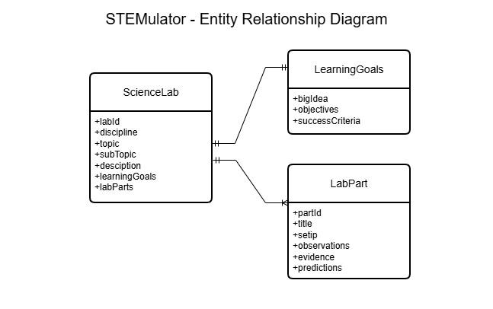
2.2 Data Model
The following JSON provides a view of the ScienceLab data model’s structure.
{
"_id": "",
"discipline": "",
"topic": "",
"subTopic": "",
"description": "",
"learningGoals": {
"bigIdea": "",
"objectives": ["o1", "o2", "o3", "o4"],
"successCriteria": ["c1", "c2", "c3", "c4"]
},
"labParts": [
{
"partId": 1,
"title": t1",
"setup": ["s1.", "s2"],
"observations": ["o1", "o2", "o3"],
"evidence": [ "e1","e2"],
"predictions": ["p1", "p2"]
},
{
"partId": 2,
"title": t2",
"setup": ["s1.", "s2"],
"observations": ["o1", "o2", "o3"],
"evidence": [ "e1","e2"],
"predictions": ["p1", "p2"]
},
{
"partId": 3,
"title": t3",
"setup": ["s1.", "s2"],
"observations": ["o1", "o2", "o3"],
"evidence": [ "e1","e2"],
"predictions": ["p1", "p2"]
},
{
"partId": 4,
"title": t4",
"setup": ["s1.", "s2"],
"observations": ["o1", "o2", "o3"],
"evidence": [ "e1","e2"],
"predictions": ["p1", "p2"]
}
]
}
2.3 Database Schema
The following schema defines the rules for how a well formed ScienceLab JSON object should be structured.
{
"$schema": "https://json-schema.org/draft/2020-12/schema",
"type": "object",
"required": [
"_id",
"_class",
"description",
"discipline",
"labParts",
"learningGoals",
"subTopic",
"topic"
],
"properties": {
"_id": {
"type": "string"
},
"_class": {
"type": "string"
},
"description": {
"type": "string"
},
"discipline": {
"type": "string"
},
"labParts": {
"type": "array",
"items": {
"type": "object",
"required": [
"evidence",
"observations",
"partId",
"predictions",
"setup",
"title"
],
"properties": {
"evidence": {
"type": "array",
"items": {
"type": "string"
}
},
"observations": {
"type": "array",
"items": {
"type": "string"
}
},
"partId": {
"type": "integer"
},
"predictions": {
"type": "array",
"items": {
"type": "string"
}
},
"setup": {
"type": "array",
"items": {
"type": "string"
}
},
"title": {
"type": "string"
}
}
}
},
"learningGoals": {
"type": "object",
"required": [
"bigIdea",
"objectives",
"successCriteria"
],
"properties": {
"bigIdea": {
"type": "string"
},
"objectives": {
"type": "array",
"items": {
"type": "string"
}
},
"successCriteria": {
"type": "array",
"items": {
"type": "string"
}
}
}
},
"subTopic": {
"type": "string"
},
"topic": {
"type": "string"
}
},
"$defs": {}
}
3. Technology Stack
3.1 UI
Category | Technology | Purpose / Rationale
Core Framework | React 18 | Primary UI library for building interactive, component-based user interfaces with efficient rendering and state updates.
Core Framework | TypeScript | Provides static typing to improve code quality, reduce runtime errors, and support maintainable, scalable development.
Routing | React Router | Enables client-side navigation between pages such as Home, Courses, Labs, and individual lab simulators without full page reloads.
Styling & Design | Tailwind CSS | Utility-first CSS framework used to rapidly build responsive, consistent layouts while minimizing custom CSS overhead.
Styling & Design | Lucide React | Icon library used for navigation and UI affordances (menus, breadcrumbs, actions) to improve usability and visual clarity.
Styling & Design | Custom CSS | Used sparingly for specialized animations, canvas effects, and UI behaviors not easily expressed through utility classes.
3.2 API
Name | Version | Description
Java | 21 | General Purpose Object Oriented Programming language
Spring Boot | 3.5.10 | Framework for building Web and REST API applications
Spring AI | 3.5.10 | Framework that provides seamless integration of AI into Spring applications
Mongo DB | 8.2 | NoSQL Document database
Maven | 3.9 | Popular build tool for Java projects
4. Component Design
4.1 Class Diagrams
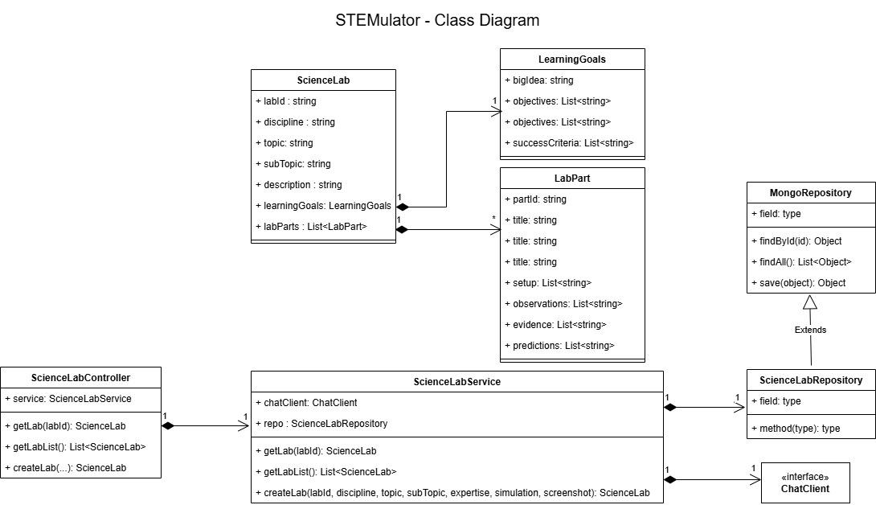
4.2 Sequence Diagram
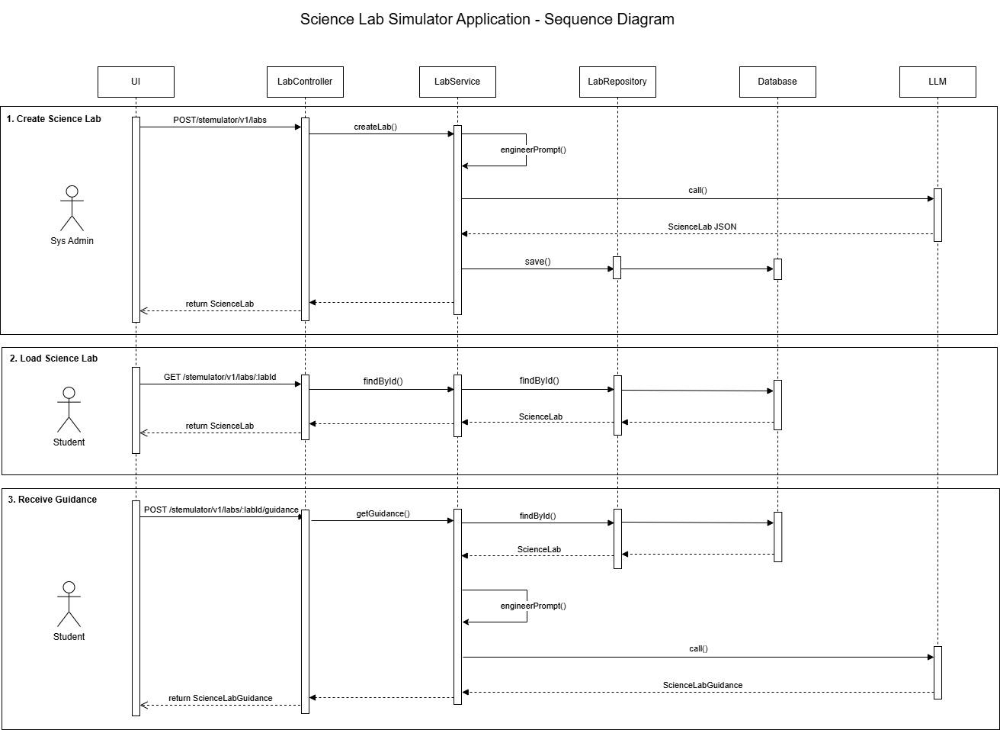
5. Quality Attribute Design
Quality Attribute Design Strategies – STEMulator
1. Performance
Quality Requirement (Week 2): The system must support responsive, real-time simulation behavior without UI lag during interaction or state updates.
Design Strategy: Controlled State Updates
Implementation Evidence:
React.useEffect(() => {
const interval = setInterval(() => {
setState(sim.getState());
}, 100);
return () => clearInterval(interval);
}, [sim]);
Explanation: Instead of triggering re-renders on every internal simulation update, the UI polls simulation state at fixed intervals. This throttling reduces rendering overhead while preserving smooth visual updates. Cleanup logic prevents memory leaks and long-running timers.
2. Usability
Quality Requirement (Week 2): The interface must guide learners through experiments while providing clear feedback and reducing cognitive load.
Design Strategy: Real-Time Feedback and Structured Lab Flow
<span>{state.generation}</span>
<span>{state.organisms.length}</span>
<span>{(state.survivalRate * 100).toFixed(0)}%</span>
Explanation: Key metrics are displayed immediately as the simulation runs, allowing students to observe cause-and-effect relationships. The lab is divided into sequential sections to guide the scientific process.
3. Maintainability
Quality Requirement (Week 2): The system must be easy to extend, refactor, and maintain.
Design Strategy: Modular Component Architecture and Strong Typing
interface LabPart {
partId: number;
title: string;
setup: string[];
observations: string[];
evidence: string[];
predictions: string[];
}
Explanation: Explicit interfaces define expectations for each lab section. Component modularity and strict typing reduce coupling and make future enhancements predictable.
4. Reliability
Quality Requirement (Week 2): The system must behave predictably and fail gracefully.
Design Strategy: Defensive Rendering and Lifecycle Management
if (!lab) {
return <PageShell>Lab not found</PageShell>;
}
Explanation: Defensive checks prevent runtime failures when invalid routes or missing data are encountered, improving system robustness.
5. Responsiveness
Quality Requirement (Week 2): The system must adapt to different screen sizes and devices.
Design Strategy: Flexible Layout and Adaptive Navigation
Explanation: A flex-based layout and collapsible sidebar ensure usability across desktop and smaller screen devices.
6. Extensibility
Quality Requirement (Week 2): The platform must support future labs and evaluation tools.
Design Strategy: Configuration-Driven Lab Structure
Explanation: Lab configuration and state structures allow new lab types and evaluators to be added without restructuring core logic.
7. Security
Quality Requirement (Week 2): The system must minimize client-side security risks.
Design Strategy: Type-Safe Input Handling
Explanation: Typed inputs and safe routing reduce exposure to malformed data and injection risks.
8. Accessibility
Quality Requirement (Week 2): The interface must be accessible to a broad range of users.
Design Strategy: Semantic HTML and Keyboard Navigation
Explanation: Semantic elements, proper contrast, and keyboard-accessible controls support accessibility best practices.
6. Implementation Guide
6.1. Development Setup
Development for STEMulator requires both backend and frontend tooling, since the API and UI are maintained in the same repository.
On the backend, the project uses a Spring Boot application backed by MongoDB. Developers are expected to have a compatible JDK installed, along with Maven or Gradle depending on the build configuration. MongoDB must be running locally, with a database named stemulator and a labs collection populated using the provided sample data file in src/main/resources/data/stemulator.labs.json.
The application also integrates with an external large language model. An API key is required and must be provided through an environment variable. This key is referenced in the application configuration so that credentials are not committed to source control.
On the frontend, the UI is built with React, TypeScript, and Vite. Developers install dependencies using npm and run the development server locally. The UI communicates with the backend through a configurable API base URL defined in a local environment file.
During development, the typical workflow is to run MongoDB, the Spring Boot API, and the React development server concurrently.
6.2. Coding Standards
The project follows consistent naming and formatting conventions to keep the codebase readable and maintainable.
React components use PascalCase and are named descriptively based on their responsibility. Files and folders use kebab-case and are organized by role, such as pages, components, simulation logic, and shared types. Variables and functions use camelCase, while constants use upper snake case. TypeScript interfaces and types also use PascalCase.
The lab data model uses terms to better reflect scientific practice and alignment with NGSS terminology.
Code formatting is intentionally simple. Two-space indentation is used throughout, line length is kept reasonable, and TypeScript’s type system is used consistently. The use of any is avoided. Comments are expected to explain why something is done, not restate what the code already makes obvious.

6.3. Testing Approach
Testing is focused on protecting core behavior rather than achieving exhaustive coverage.
At the unit level, frontend tests focus on simulation logic, hooks, and small reusable components. Backend unit tests focus on service logic and request validation. These tests are designed to run quickly and provide fast feedback during development.
Integration tests validate key workflows, such as loading a lab, running a simulation step, submitting evidence, and requesting AI guidance. These tests ensure that components work together as expected.
End-to-end testing is intentionally limited due to the practicum timeline. Only a small number of critical paths are covered, primarily to ensure that the full lab workflow functions correctly from the user’s perspective.
6.4. Git Workflow
The project uses a lightweight Git workflow suitable for a small team.
The main branch is kept stable and demo-ready. Feature work is done on short-lived feature branches, with bug fixes and documentation changes following similar naming conventions. Changes are merged through pull requests rather than direct pushes.
Commit messages follow a consistent format that clearly describes the scope and intent of each change. Pull requests include a brief explanation of what changed and why, screenshots for UI changes when applicable, and confirmation that the code builds and runs locally.
Before merging, at least one other team member reviews the changes to ensure quality and consistency.

7. Appendix
7.1 Response JSON - ScienceLab
{
"labId": "HS-LS4-2",
"discipline": "Life Science",
"topic": "Biological Evolution: Unity and Diversity",
"subTopic": "Natural Selection",
"description": "This virtual lab explores the principles of natural selection using a simulation app to model how different traits affect survival and reproduction in a rabbit population.",
"learningGoals": {
"bigIdea": "Natural selection is a key mechanism of evolution that affects the diversity of life.",
"objectives": [
"Understand the role of environmental factors in natural selection.",
"Analyze how specific traits impact the survival of a population.",
"Evaluate the effects of mutations on population dynamics.",
"Synthesize data to draw conclusions about evolutionary changes."
],
"successCriteria": [
"Demonstrate the ability to collect and analyze data from the simulation.",
"Effectively predict outcomes based on specific trait changes.",
"Articulate connections between environmental factors and trait survival.",
"Create a comprehensive report summarizing findings and conclusions."
]
},
"labParts": [
{
"partId": 1,
"title": "Introduction to Natural Selection",
"setup": [
"Open the Natural Selection Lab Simulation app.",
"Select the initial population of rabbits with varying traits."
],
"observations": [
"How do the different traits of the rabbits affect their visibility in the environment?",
"What do you notice about the initial population's distribution of traits?",
"How do environmental factors (e.g., food availability) seem to influence the rabbits?"
],
"evidence": [
"Record the initial population counts of each trait (fur color, ear type, tooth size).",
"Capture a screenshot of the initial trait distribution graph."
],
"predictions": [
"Which traits do you think will be favored in the next generation?",
"How might changes in the environment affect future generations of rabbits?"
]
},
{
"partId": 2,
"title": "Simulating Environmental Changes",
"setup": [
"Introduce a new environmental factor, such as predators.",
"Run the simulation for 10 generations."
],
"observations": [
"What changes do you observe in the rabbit population over generations?",
"How do specific traits appear to influence survival rates?",
"Is there a noticeable shift in the dominant traits among the rabbits?"
],
"evidence": [
"Document the population counts of each trait at each generation.",
"Analyze and record the survival rates of each trait."
],
"predictions": [
"Which traits do you think will decrease in frequency?",
"How do you expect the population to stabilize in response to the new predator?"
]
},
{
"partId": 3,
"title": "Exploring Mutations and Variation",
"setup": [
"Add a mutation to the rabbit population (e.g., longer teeth).",
"Run the simulation for 10 more generations."
],
"observations": [
"How does the introduction of mutations affect the population?",
"What variations in traits do you notice emerging?",
"Do any new traits become more advantageous?"
],
"evidence": [
"Track the occurrences of the new trait and its impact on survival.",
"Create a graph showing the changes in trait frequency over generations."
],
"predictions": [
"Will the new mutation become prevalent in future generations?",
"How might these mutations interact with environmental changes?"
]
},
{
"partId": 4,
"title": "Analyzing the Data and Formulating Conclusions",
"setup": [
"Review the data collected from all generations.",
"Analyze how natural selection has shaped the rabbit population."
],
"observations": [
"What trends do you notice in the data about trait survival?",
"How do the results support or contradict your initial predictions?",
"What role did environmental factors play in shaping the population?"
],
"evidence": [
"Summarize the data trends in a final report.",
"Create a visual representation (chart) of trait frequency changes."
],
"predictions": [
"What future changes might occur if environmental conditions shift again?",
"How could different mutations further influence the population?"
]
}
]
}
7.2 Response JSON - ScienceLab List
[
{
"labId": "HS-ESS1-2",
"discipline": "Earth and Space Science",
"topic": "Earth’s Place in the Universe",
"subTopic": "Earth and the Solar System",
"description": "This virtual science lab uses the My Solar System Lab Simulation app to explore the dynamics of the solar system. Students will engage in a case-study method to investigate the relationships between mass, distance, and gravitational forces in planetary motion.",
"learningGoals": {
"bigIdea": "The gravitational interactions between celestial bodies govern the structure and behavior of the solar system.",
"objectives": [
"Understand how mass and distance affect gravitational forces.",
"Analyze the relationship between orbital speed and distance from the sun.",
"Investigate how changes in mass impact orbital dynamics.",
"Explore the interactions of multiple bodies within the solar system."
],
"successCriteria": [
"Demonstrate the ability to manipulate simulation parameters effectively.",
"Accurately document observations and data collected during the simulation.",
"Make informed predictions based on scientific reasoning.",
"Engage in critical thinking about the relationships and dynamics within the solar system."
]
},
"labParts": [
{
"partId": 1,
"title": "Investigating Gravitational Forces",
"setup": [
"Open the My Solar System Lab Simulation app.",
"Set the mass of the sun to 250.0 (10^28 kg) and the mass of a planet to 25.0 (10^28 kg).",
"Adjust the distance between the sun and the planet to 1 AU.",
"Start the simulation and observe the motion."
],
"observations": [
"How does the planet's orbit change as you adjust its mass?",
"What happens to the gravitational force as the distance between the sun and the planet is altered?",
"How does the planet's speed change in relation to its distance from the sun?"
],
"evidence": [
"Document the gravitational force and orbital speed in a CSV file."
],
"predictions": [
"What will happen to the planet's orbit if its mass is increased?",
"How will the gravitational force change if the distance is doubled?"
]
},
{
"partId": 2,
"title": "Effect of Distance on Orbital Speed",
"setup": [
"Reset the simulation.",
"Keep the mass of the sun at 250.0 (10^28 kg) and the mass of the planet at 25.0 (10^28 kg).",
"Set the distance to 2 AU and start the simulation.",
"Record the planet's orbital speed."
],
"observations": [
"What differences do you notice in the planet's speed at 2 AU compared to 1 AU?",
"How does the gravitational pull affect the planet's speed at this distance?",
"Does the planet maintain a consistent speed throughout its orbit?"
],
"evidence": [
"Record the planet's orbital speed at both distances in a CSV file."
],
"predictions": [
"How will the orbital speed change if the distance is increased to 3 AU?",
"What do you think will happen if the distance is decreased to 0.5 AU?"
]
},
{
"partId": 3,
"title": "Mass and Orbital Dynamics",
"setup": [
"Reset the simulation.",
"Set the mass of the sun to 250.0 (10^28 kg).",
"Set the mass of the planet to 50.0 (10^28 kg).",
"Maintain the distance at 1 AU and start the simulation."
],
"observations": [
"How does the increased mass of the planet affect its orbit?",
"What changes do you observe in the gravitational force exerted on the planet?",
"How does this mass change impact the planet's speed?"
],
"evidence": [
"Document the gravitational force and orbital speed in a CSV file."
],
"predictions": [
"How might the planet's orbit change if its mass were decreased to 10.0 (10^28 kg)?",
"What would happen if both the sun and planet masses were increased simultaneously?"
]
},
{
"partId": 4,
"title": "Exploring Multiple Bodies in the System",
"setup": [
"Reset the simulation.",
"Set the mass of the sun to 250.0 (10^28 kg).",
"Set the mass of two planets: one at 25.0 (10^28 kg) and another at 10.0 (10^28 kg).",
"Set the distances to 1 AU and 1.5 AU respectively, then start the simulation."
],
"observations": [
"How do the orbits of the two planets interact with each other?",
"What happens to the gravitational forces acting on each planet?",
"How do the speeds of the planets compare to each other?"
],
"evidence": [
"Collect data on the orbits and speeds of both planets in a CSV file."
],
"predictions": [
"What will happen if the distance between the two planets is reduced?",
"How might the orbits change if one planet's mass is significantly increased?"
]
}
]
},
{
"labId": "HS-LS4-2",
"discipline": "Life Science",
"topic": "Biological Evolution: Unity and Diversity",
"subTopic": "Natural Selection",
"description": "This virtual lab explores the principles of natural selection using a simulation app to model how different traits affect survival and reproduction in a rabbit population.",
"learningGoals": {
"bigIdea": "Natural selection is a key mechanism of evolution that affects the diversity of life.",
"objectives": [
"Understand the role of environmental factors in natural selection.",
"Analyze how specific traits impact the survival of a population.",
"Evaluate the effects of mutations on population dynamics.",
"Synthesize data to draw conclusions about evolutionary changes."
],
"successCriteria": [
"Demonstrate the ability to collect and analyze data from the simulation.",
"Effectively predict outcomes based on specific trait changes.",
"Articulate connections between environmental factors and trait survival.",
"Create a comprehensive report summarizing findings and conclusions."
]
},
"labParts": [
{
"partId": 1,
"title": "Introduction to Natural Selection",
"setup": [
"Open the Natural Selection Lab Simulation app.",
"Select the initial population of rabbits with varying traits."
],
"observations": [
"How do the different traits of the rabbits affect their visibility in the environment?",
"What do you notice about the initial population's distribution of traits?",
"How do environmental factors (e.g., food availability) seem to influence the rabbits?"
],
"evidence": [
"Record the initial population counts of each trait (fur color, ear type, tooth size).",
"Capture a screenshot of the initial trait distribution graph."
],
"predictions": [
"Which traits do you think will be favored in the next generation?",
"How might changes in the environment affect future generations of rabbits?"
]
},
{
"partId": 2,
"title": "Simulating Environmental Changes",
"setup": [
"Introduce a new environmental factor, such as predators.",
"Run the simulation for 10 generations."
],
"observations": [
"What changes do you observe in the rabbit population over generations?",
"How do specific traits appear to influence survival rates?",
"Is there a noticeable shift in the dominant traits among the rabbits?"
],
"evidence": [
"Document the population counts of each trait at each generation.",
"Analyze and record the survival rates of each trait."
],
"predictions": [
"Which traits do you think will decrease in frequency?",
"How do you expect the population to stabilize in response to the new predator?"
]
},
{
"partId": 3,
"title": "Exploring Mutations and Variation",
"setup": [
"Add a mutation to the rabbit population (e.g., longer teeth).",
"Run the simulation for 10 more generations."
],
"observations": [
"How does the introduction of mutations affect the population?",
"What variations in traits do you notice emerging?",
"Do any new traits become more advantageous?"
],
"evidence": [
"Track the occurrences of the new trait and its impact on survival.",
"Create a graph showing the changes in trait frequency over generations."
],
"predictions": [
"Will the new mutation become prevalent in future generations?",
"How might these mutations interact with environmental changes?"
]
},
{
"partId": 4,
"title": "Analyzing the Data and Formulating Conclusions",
"setup": [
"Review the data collected from all generations.",
"Analyze how natural selection has shaped the rabbit population."
],
"observations": [
"What trends do you notice in the data about trait survival?",
"How do the results support or contradict your initial predictions?",
"What role did environmental factors play in shaping the population?"
],
"evidence": [
"Summarize the data trends in a final report.",
"Create a visual representation (chart) of trait frequency changes."
],
"predictions": [
"What future changes might occur if environmental conditions shift again?",
"How could different mutations further influence the population?"
]
}
]
}
]
7.3 Response JSON - ScienceLab Guidance
{
"guidance": "Barack, you've made some excellent observations regarding the relationship between fur color and visibility to predators, as well as the impact of environmental factors on population size. However, let's refine your setup and predictions for Part 1 to align with the lab objectives. First, ensure that you open the Natural Selection Lab Simulation app and select an initial population of rabbits with varying traits, which is crucial for observing how traits affect survival. Your observations should directly connect to the traits of the initial population. For your predictions, consider focusing on which specific traits might be favored based on the initial traits displayed in your CSV data. For example, you could predict that 'white fur' will be more advantageous in snowy environments, while 'brown fur' might be less favorable. Keep up the good work and ensure to document your initial population counts and trait distributions for future reference."
}

